

**Project ROME**

**User Guide**

**Rasool Abbas**

**Onel Jimenez**

**Michael McFarlin**

**Ethan Wharton**

Contents

1 Dashboard 3

1.1 Navigation 3

1.2 Search Bar 3

1.3 Legal Documents 3

1.4 Logging in 4

1.5 Profile Icon 4

2 Accounting 5

2.1 Logging In 5

2.2 Registering 6

3 Fundraisers 7

3.1 General 7

3.2 Donating to a Fundraiser 8

3.2.1 Donation Prompt 8

3.2.2 Donation Payment 9

3.3 Create a Fundraiser 10

3.4 Edit a Fundraiser 11

4 Profile Settings 12

# 1 Dashboard

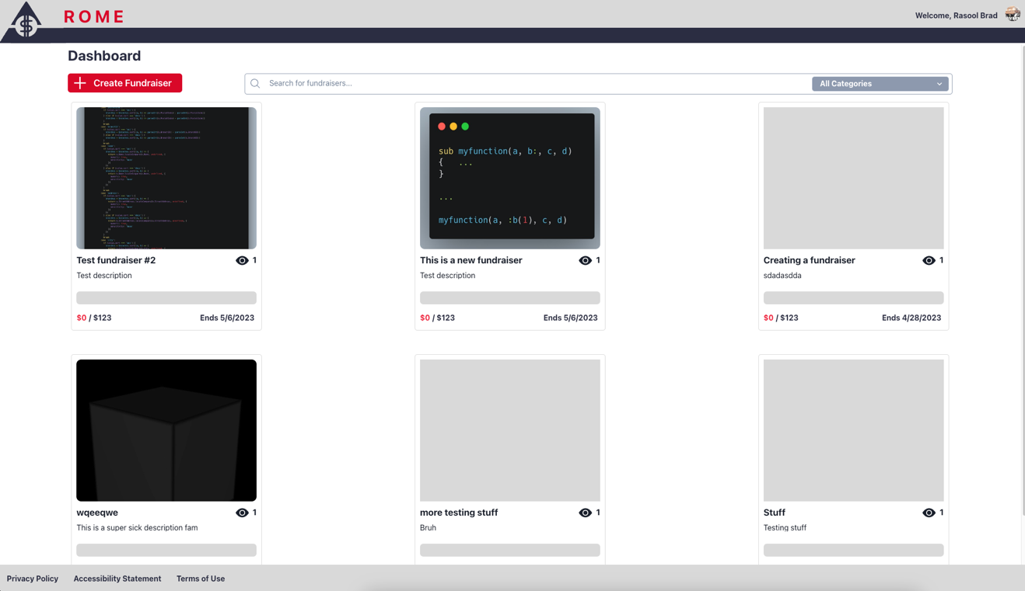

## 1.1 Navigation

The dashboard shows all the available (and expired) fundraisers by default. As you scroll, more fundraisers will be loaded until all the fundraisers are shown on the page.

## 1.2 Search Bar

The search bar can be useful for finding specific fundraisers. To look for a fundraiser, enter the fundraiser’s name in the search bar. The page will immediately load fundraisers that match the term that you’ve searched for.

You can also use the grey dropdown menu to search for certain categories. See here for more information regarding categories.

## 1.3 Legal Documents

On any page, you can access the legal documents such as the Privacy Policy and Terms of Use, along with the Accessibility Statement at the bottom of the page.

## 1.4 Logging in

To make, donate to, or revise fundraisers, you’ll need to sign in. You can navigate to the login page by clicking the Log In button in the top right.

## 1.5 Profile Icon

When signed in, an icon will appear in the top right alongside your name. If you click on this link, you will see the following prompt;

Clicking on “Profile” will send you to the profile settings.

Clicking on “Sign Out” will sign you out of your account.

# 2 Accounting

## 2.1 Logging In

Here you can fill in your email address and password. Should your login information be incorrect, you will be prompted with an error. If you log in successfully, you will be returned to the dashboard.

If you have forgotten your password, click “Forgot password?” You will be asked to enter your email address. You will then be sent an email with a 6-digit code for verification. Enter the code in the textbox. You will then be asked to fill in a new password and confirm that new password. You can now log in using this new password.

If you have never registered to the app before, click “Create one here!” below the Login button.

## 2.2 Registering

Here you can make a new account. The account will keep track of all your fundraisers, donations* and comments*.

Fill in the relevant information (first name, last name, email, password). You will need to confirm your password in the “Confirm” text box to make sure that your password is correct. Upon clicking the “Register” button, you will be returned to the login page (so long as your email is valid and your passwords match).

*The app will not save donations and comments that are marked as anonymous.

# ­­­­3 Fundraisers

## 3.1 General

The fundraiser page shows detailed information of a particular fundraiser. You can see images, the description of a fundraiser, the category of the fundraiser, when the fundraiser is over, comments by other users on the fundraiser, and the donations made to the fundraiser by other users. Comments and donations are listed by newest first.

Every fundraiser has an attributed category from the following list;

* Medical
* Education
* Disaster Relief
* Environment
* Animal Welfare
* Financial Assistance
* Religion
* Community
* Political
* Other (for fundraisers that do not fit into any other category)

## 3.2 Donating to a Fundraiser

### 3.2.1 Donation Prompt

You can donate to a fundraiser so long as the fundraiser has not concluded. By clicking on the “Donate” button, you will be prompted with the following;

Here you can fill in the amount that you’d like to donate to the fundraiser. You can also include a comment in the donation if you choose.

When you select “Anonymous Donation,” the message and donation are anonymized and not attributed to you. Not even an administrator will be able to attribute the donation and (if applicable) the message to you.

Click “Proceed to Payment” to continue.

### 3.2.2 Donation Payment

Here you will be given a confirmation of the total amount you wish to donate, along with the fundraiser you will be donating to. Fill in the information as shown to proceed with your payment.

Note that the app only supports Mastercard and VISA payments currently.

If all the information is valid, you will be returned to the fundraiser where you will see your donation and comment (if applicable).

## 3.3 Create a Fundraiser

To create a fundraiser, click “Create a Fundraiser” on the dashboard. You will be redirected to this window;

Here you can fill out all of the information related to your fundraiser;

* A title that fits a summary of what the intentions of your fundraiser are. Your title must be at least 3 characters long, but no longer than 256 characters.
* You can upload up to 5 images related to your fundraiser.
* A detailed description of what your fundraiser is for. You can include a description of up to 5026 characters.
* An end goal in a dollar amount. You can leave it as 0 if you do not have an intended goal or set any number amount.
* An end date that marks when your fundraiser is over. You must set an end date.

When you click create, you will be redirected to your newly created fundraiser.

## 3.4 Edit a Fundraiser

You can edit a fundraiser by clicking the “Edit” button on the fundraiser page.

Note that you can only edit fundraisers that you have made. You will not see the “Edit” button on fundraisers that you have not made.

You will be prompted with the above page. The page is similar to fundraiser creation; edit the necessary fields, then click “Save” to finalize your changes.

# 4 Profile Settings

Here you can edit your profile picture, your name, and/or your email address.

Click the “Edit” button to make changes. Once you are satisfied with your changes, click “Save”.